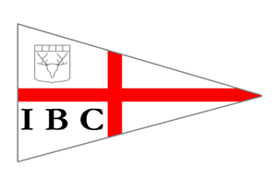

Invergordon Boating Club
SPRING NEWSLETTER
May, 2023

A Busy Start to the Season

Open Day and Dinghy Course
The 2023 sailing season was kicked off with a successful open day which attracted a steady stream of people who came for the ‘Discover Sailing’ sessions, the wonderful baking and soup provided by our very helpful volunteers, a taster of powerboating and to generally come and see what our club has to offer. Thank you to our members who volunteered on the day which made everything run smoothly. The fantastic weather also helped!
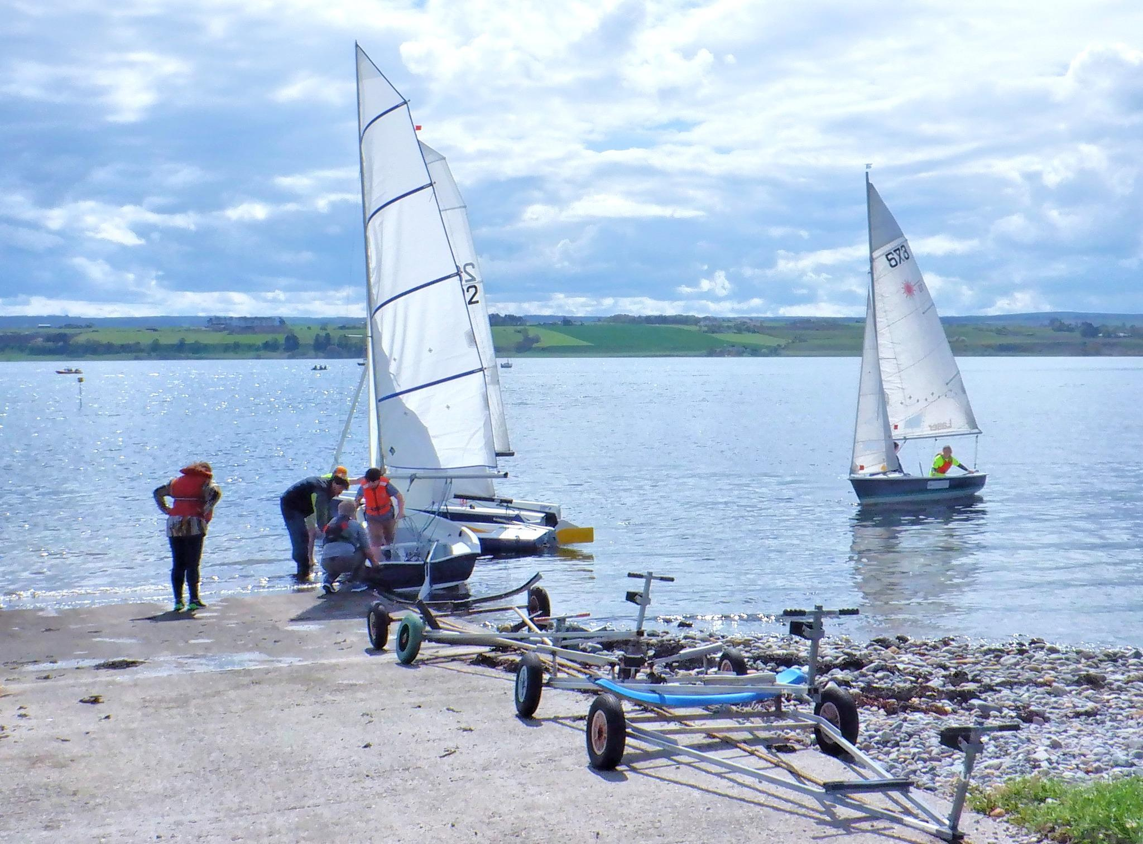

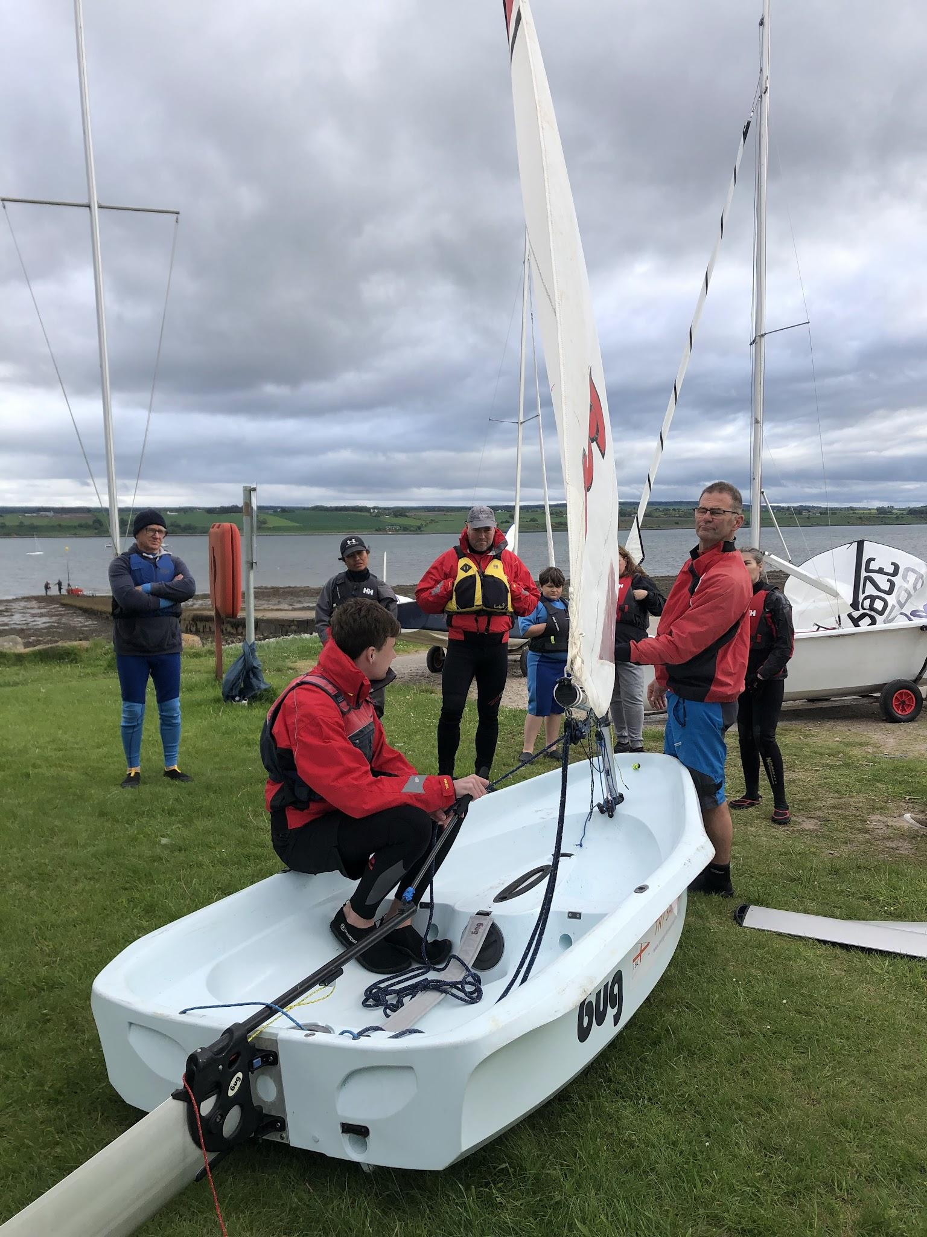
Following the open day, 12 keen new sailors started the RYA level 1 course which is due to finish in June, by which point the participants should be able to sail in all directions and take the dinghies to and from the shore. After the course, alternative Tuesday evenings will be for ‘beginners and improvers’ in the hope that by the autumn series, new sailors will have built up the confidence to take part in the weekly races.
Remember you can view the calendar on the club website.

Spring Series
The spring keel and dinghy series is already about to come to a close. The weather has been kind to us this spring which has made dinghy sailing much more appealing than some years! Thank you to John Edmonson who continually works hard to compile all the results which will be posted soon. Thank you also to those who volunteered to do OOD and safety boat on these evenings, without which we would not be able to race. Please check if you are down for any duties in our handbook here.
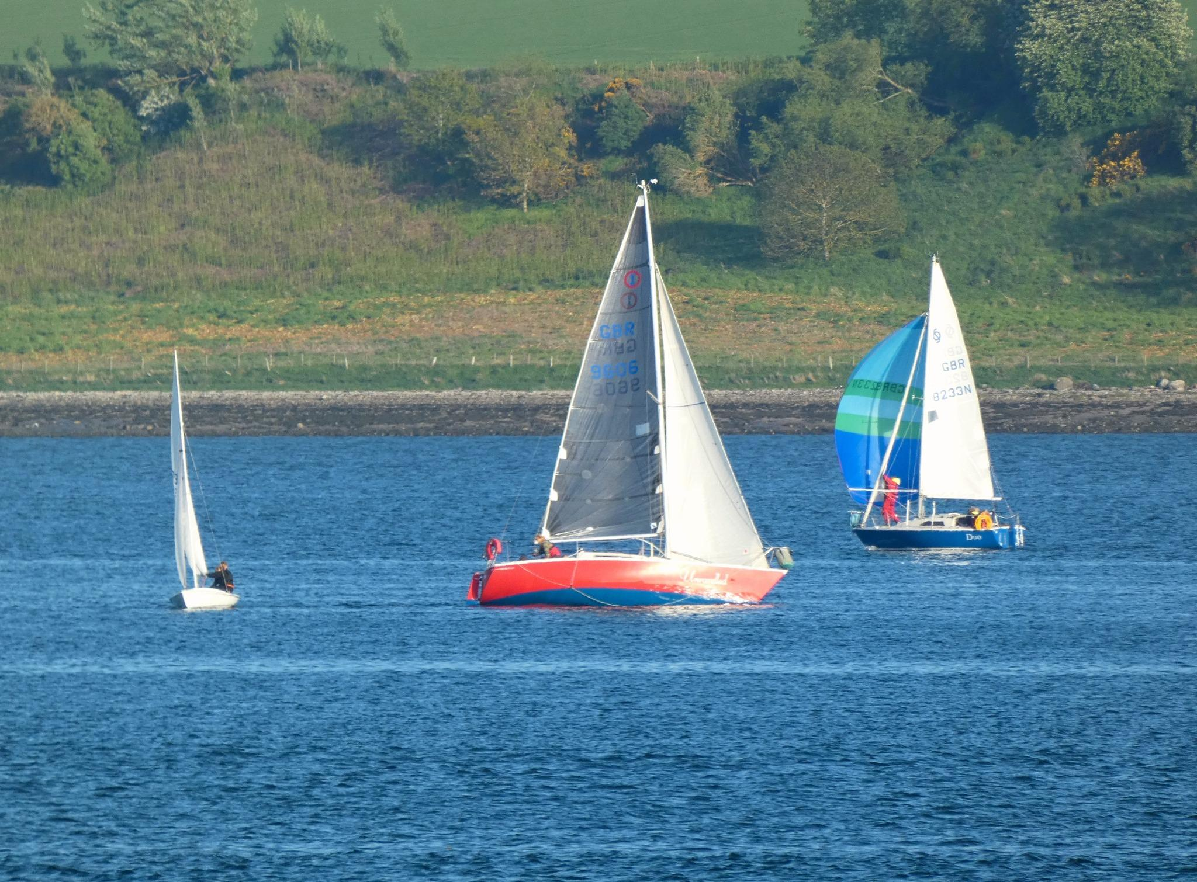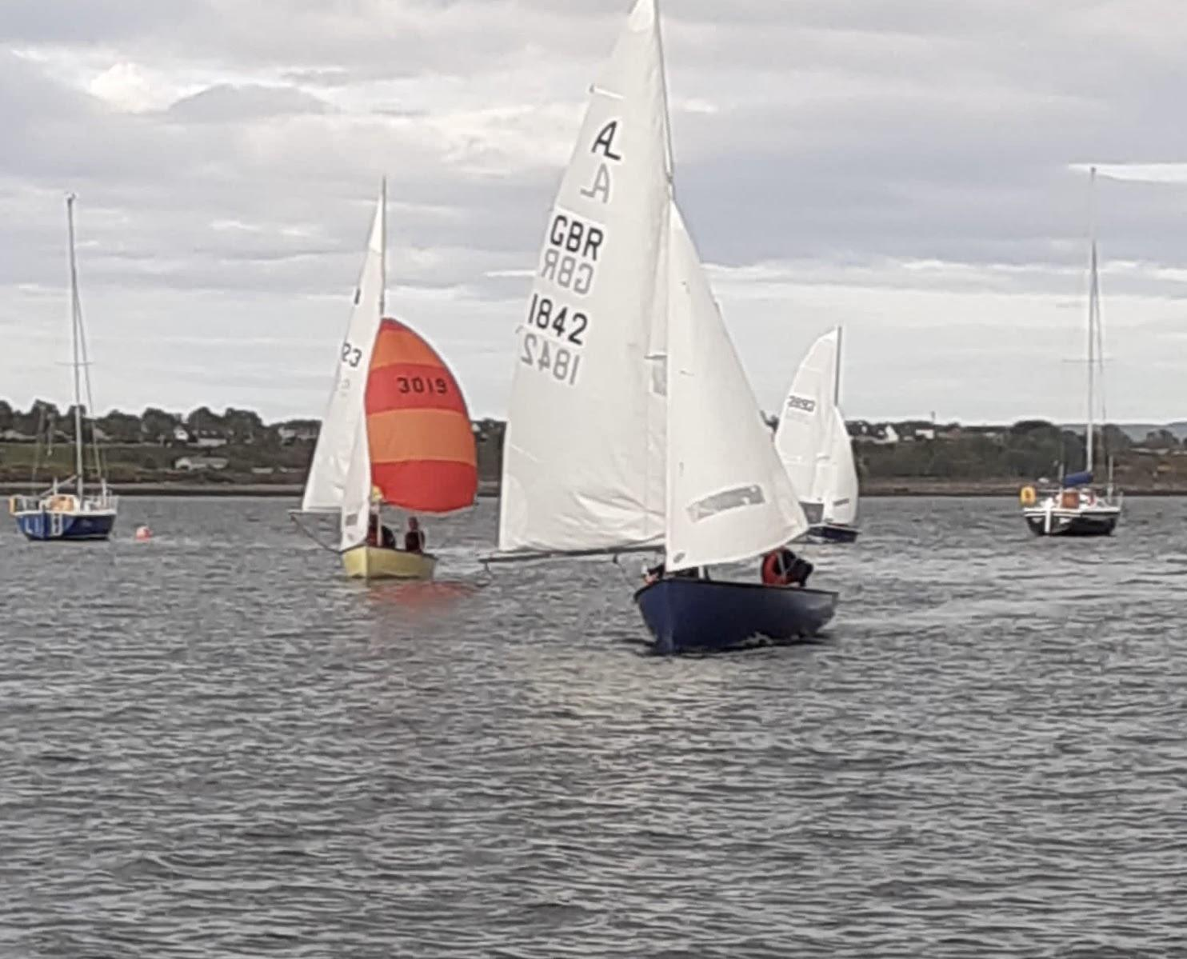

Moray Firth Cruiser Race
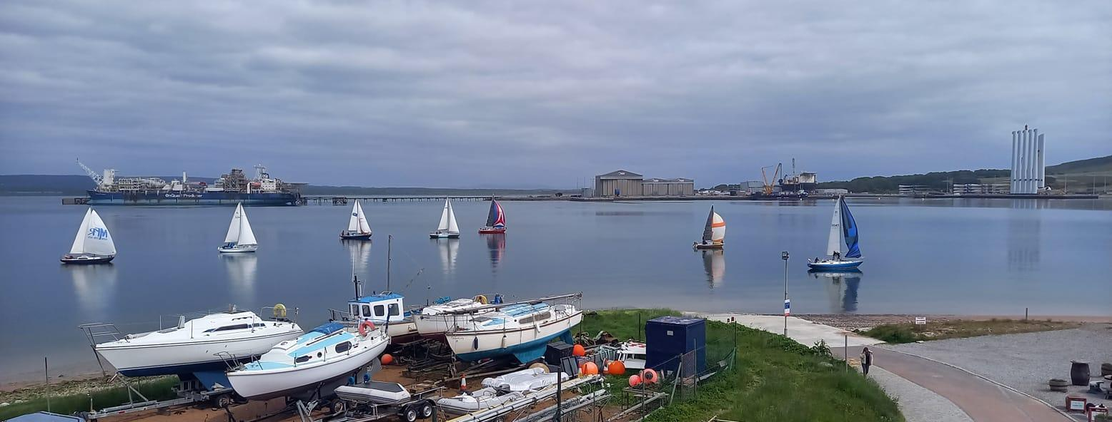
A big thank you to John Burgis and Dave Bilsland who were the race officers for the day, also George and Ann at Cromarty BC for allowing us to use the tower again and ensuring that everything worked. And an equally big thank you to the competitors who came out in numbers to make a success of the day. Congratulations to Callum Stirling who came 1st in the class 1 and to Greg Fisher in class 2.

Upcoming events
Dinghy regatta: Sunday 4th June
Cruise/race to the Storehouse at Foulis: Saturday 17th June

Member Boats, Outboards and Trailers
We still have many boats, outboards and inflatables that have not been used in quite some time, some of which we don’t know who they belong to. We need owners to do the following:
- If you have a boat that you no longer plan to use then please look at selling or disposing of your boat.
- Mark any trailers, outboards or inflatable tenders with your name within the next 4 weeks. Anything that we can’t identify will be removed.
We will be contacting owners throughout the year about this as we need the space for club boats and actively used boats. The boatyard should not be used for long term storage. We are also going to move unused boats up to the back in the meantime so that the frequently used club boats can be kept together in a convenient place. If you object to your boat possibly being shifted then please get in touch.

Clothing
If you would like some Invergordon Boating Club clothing, I can arrange the following items which would be in navy blue. These prices are for screen printed, I can also organise embroidered items but just waiting for a price for these. If you would like to order then message me on 07739905119. Other items are available too such as hats, aprons, jackets, bags…. Just let me know what you fancy and I’ll get a price.

Item | Price
T-shirt | £13
Polo shirt | £15
Hoodie | £20
Sweatshirt | £20

Easyfundraising
Please remember to use easyfundraising every time you shop online! Over 7,000 brands will donate, so you can raise FREE donations for us no matter what you’re buying. These donations really help us out, we have raised £131.90 in the last few months, so please sign up if you haven’t yet. It’s easy and FREE! You can get started at https://www.easyfundraising.org.uk/causes/invergordon-boating/?utm_campaign=raise-more&utm_medium=email&utm_content=rm-en-n2
Inga Ovenstone

