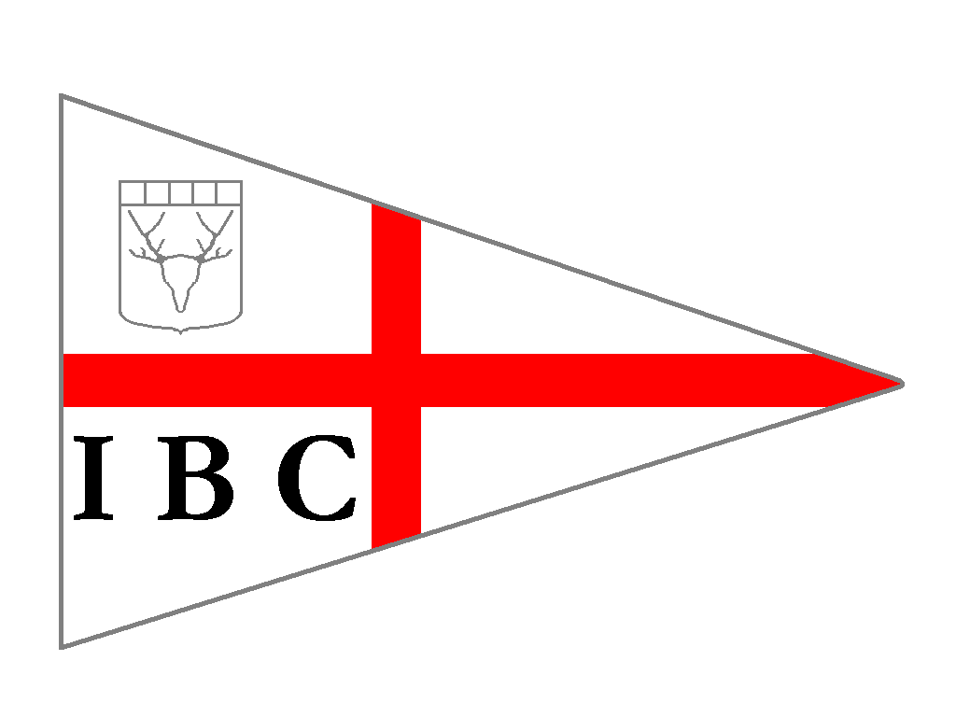
Invergordon Boating Club – Established 1901

The subscription year runs from January 1st, new memberships are subject to committee approval. Membership does not provide automatic space in the club compound.

Membership grade - Adult/Family/Junior

Amount - £75/£95/£15

To help us maintain or club records you are requested to fill in/update the details below

Name -

Family members for family membership -

Address -

Telephone number -
Mobile number -

E- Mail address –

Communication by the committee to the members is all by email.

Please indicate your intentions for joining the club, for example, learning to sail, looking to crew, intending to race..

Boat Name, type, length and description (if applicable)

Please read the new membership information leaflet before returning this form.
I agree to be bound by the rules of the club as set out in the Constitution [available on the IBC Website] and have read and agree to the Privacy Notice (see over).
Signed

Date

Please email this form to ibcmembership7@gmail.com

PRIVACY NOTICE

Invergordon Boating Club (IBC) is collecting this data for the purposes of keeping you informed about IBC activities, news, updates etc. as a member of the club.

The data will not be used for any other purpose or shared with any third party. Your details will be retained for the period of your paid up membership and for a further 3 years. If you have a boat/trailer in the club compound the club will retain your details for as long as the boat/trailer is in the compound.

You may withdraw your consent for us to hold this data after your membership has expired at any time, subject to having no property in the compound, by emailing ibcmembership7@gmail.com

