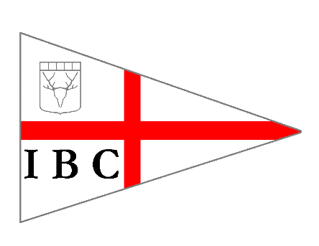
Invergordon Boating Club [Established 1901]

IBC Dinghy Regatta 2015

Notice of Race

1. Date 30th+ 31st May 2015
2. At Invergordon Boating Club; B 817, Shore Road, By Rosskeen, Invergordon
3. Organized by IBC
4. Racing will take place under the Racing Rules of Sailing.
5. Racing will be for dinghies on a handicap system using the Portsmouth Yardstick handicap. A separate start will be provided for the RS400 class if 6 or more entries are received.
6. Entries should sent to Sailing Secretary [George Shields - shieldstech@btinternet.com] Entries will be accepted up to 1 hour before first race start. Fees are £20 for a double hander, £15 single hander. [Excluding catering-details with SI]
7. The first race will start at 1300 30/05/2015 with a programme of 6 races over the 2 days
8. See entry form attached or on IBC Website.
9. Sailing instructions will be provided on the day of race.
10. Trophies. Handicap racing will be for the IBC Balconie Challenge Cup 1905. RS 400s will race for the IBC 400 Challenge Trophy

